EXP-2 Determination and plotting of Electric field and Electric flux density in sphere full of charges with varying radius.
Aim:
To write program for electric field and electric flux density in sphere using SCILAB.
Software required:
•SCILAB version 6.0.1
Practical output :
Test case -1
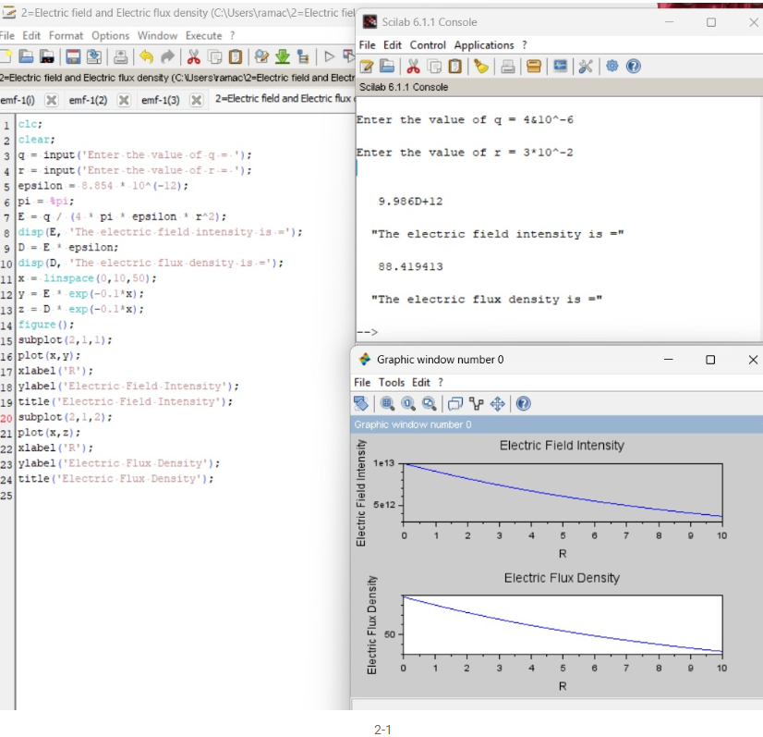

Test case-2 :

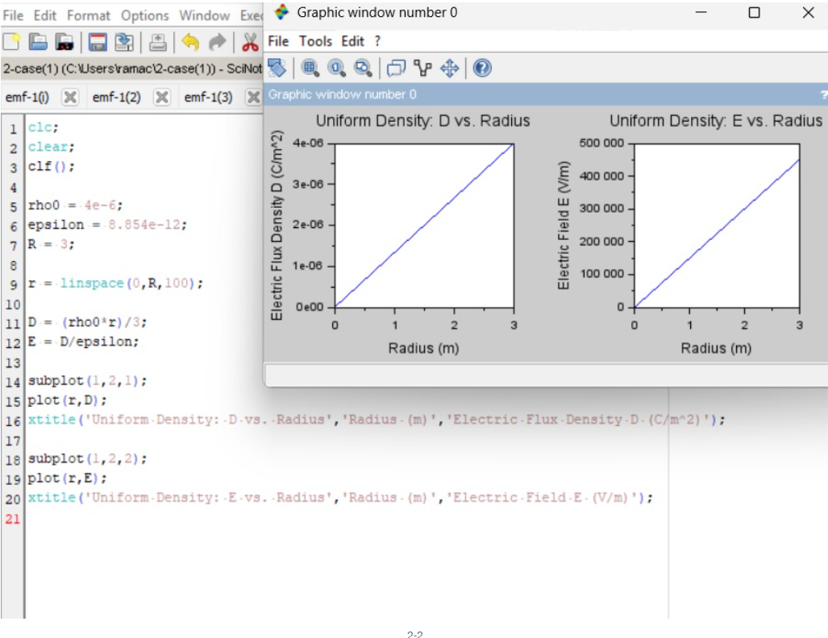

Test case-3:
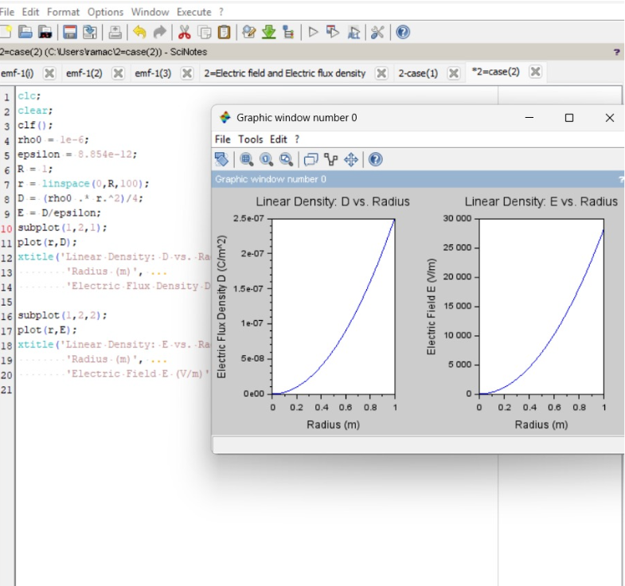

Theoretical output:

Test case -1

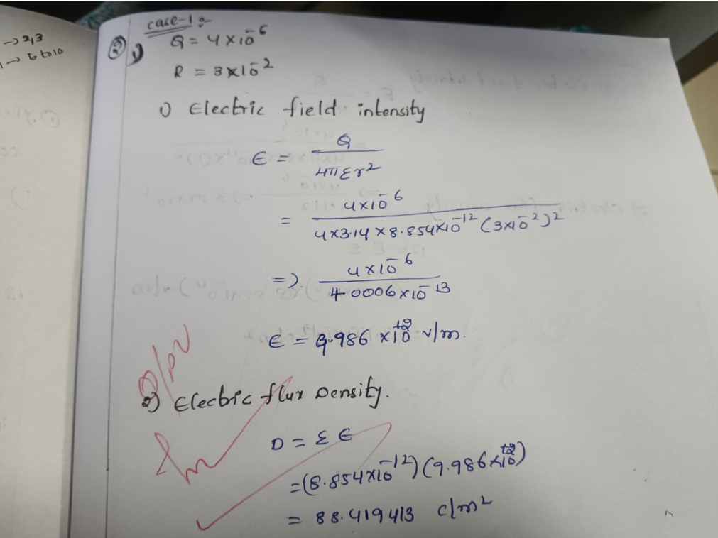

Test case-2:
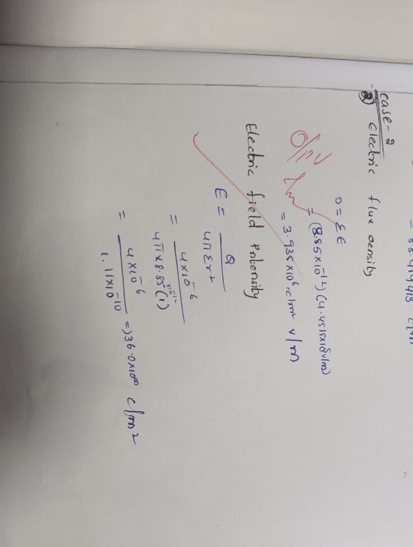
Test case-3:
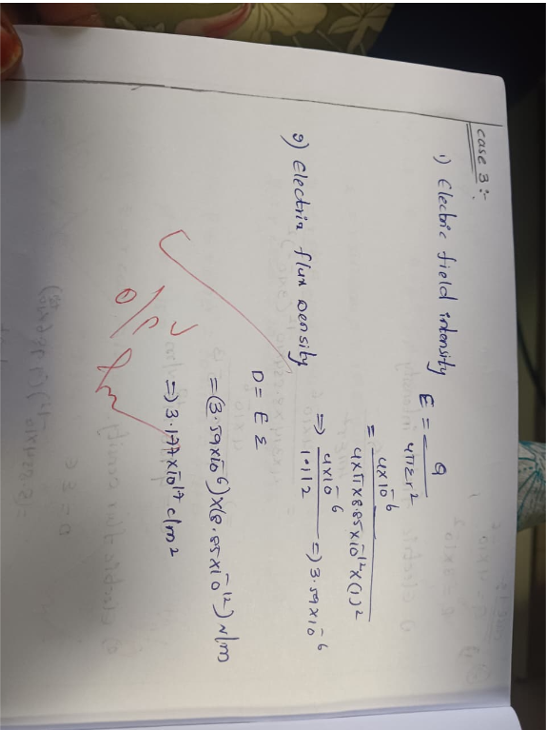
Result:
Thus the program was verified for electric field and electric flux density in sphere using SCILAB was successfully.

